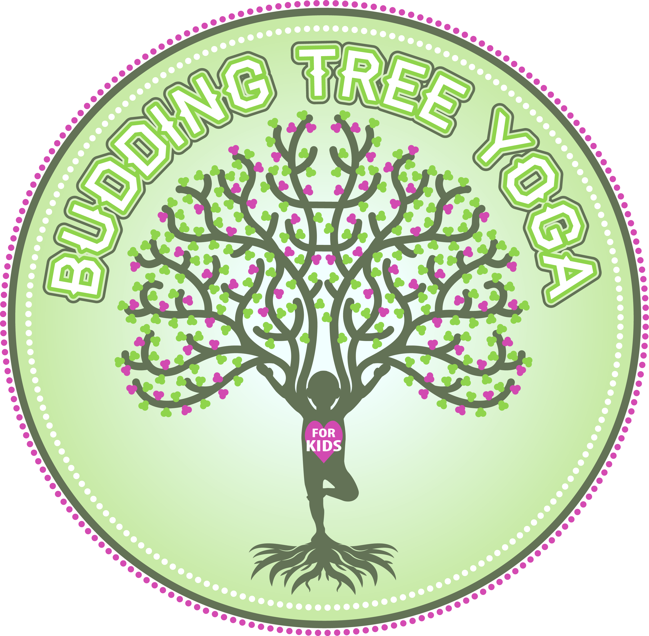BUDDING TREE YOGA FOR KIDS
Summer Camp 2015 Registration

CHILD’S NAME/AGE__________________________________________________________

PARENT’S NAME and email address _______________________________________________________________________

PHONE NUMBER ______________________________________________

Please check the class you are interested in joining:

Silly Saturday
3 classes $30
June 22, 24, 26

1030am – 1130am (3-6 year olds)_______________________
1130am – 1230pm (3-6 year olds)_______________________

3 classes $30
July 13, 15, 17
1030am – 1130am (3-6 year olds)_______________________
1130am – 1230pm (3-6 year olds)_______________________

Please print, sign and mail this form with a check for the appropriate amount to Julie Leatherbarrow 51 Boll Dr. Elma, NY 14059. You can also charge by phone by calling (716) 597-5759

ACKNOWLEDGMENT OF ASSUMPTION OF RISKS
RELEASE, WAIVER & INDEMNIFICATION
As a condition for my participation in yoga classes and programs (“Activities”), I hereby execute this release, waiver of liability, indemnity and assumption of the risk agreement (“Waiver and Release”) on my own behalf. I am aware that the yoga exercises which I will be participating in presents a risk of bodily injury. I affirm that I am physically, emotionally and mentally capable of participating in the yoga exercises and that I am not under a doctor’s care for any reason that may make my participation dangerous to myself or others. I certify that I am voluntarily participating in these activities and I assume all risks, consequences, and potential liability for this participation. I give my permission for Yoga for Life and emergency personnel to make necessary first aid decisions in the event of accident, injury, or illness to myself.
I HEREBY RELEASE, WAIVE, DISCHARGE AND AGREE NOT TO JULIE LEATHERBARROW AND BUDDING TREE YOGA FOR KIDS, OR EAST AURORA MONETESSORI, YOGAKIDS INTERNATIONAL CORPORATION, OR THEIR EMPLOYEES, INSTRUCTORS, VOLUNTEERS, AND THEIR SUCCESSORS, HEIRS AND ASSIGNS (JOINTLY “RELEASEES”) FOR ANY AND ALL CLAIMS, DEMANDS, LOSSES OR DAMAGES ON ACCOUNT OF ANY INJURY ARISING OUT OF THE ACTIVITIES.
I agree that this Waiver and Release is intended to be as broad and inclusive as is permitted by the law of the state in which the activities takes place, and that if any portion is held invalid, it is agreed that the balance shall continue in full legal force and effect. If, despite this Waiver and Release, I make a claim against any of the Releasees, the participant (or in the case a claim is made on behalf of a child, the parent(s) and/or legal guardian(s)) will reimburse the Releasee(s) for any money which such Releasee(s) incur in defending the action, including but not limited to damages and legal fees and costs.
I have read this Waiver and Release, fully understand its terms, understand that I have given up substantial rights by signing it, and have signed it freely and voluntarily without any inducement, assurance, or guarantee being made to me and intend my signature to be complete and unconditional release of all liability to the greatest extent allowed by law.

This document shall be valid for all future Activities I may participate in.

Name of Participant: _______________________________________________________________________

Date: ________________________________________________________________________

